## Wordle

• is_category(C):

Makes sure the category entered by the user in valid.

• categories(L):

Makes sure L has all available categories.

• available_length(L):

Makes sure the length entered by the user is a valid length.

• pick_word(W,L,C):

Chooses a word from the list returned by the helper predicate listofpossiblewords/3.

• correct_letters(L1,L2,CL):

Returns a list with the letters of L1 (the word the user enters) that match the letters in L2(the wordle).

• correct_positions(L1,L2,PL):

Returns a list of the letters in L1 that match the position of the letters in L2.

• listofpossiblewords(W,L,C):

Returns a list of all words in category C that have the length L.

• choosethecategory(L):

Gets category from the user.

• length(X):

Gets length of word from the user.

•addfact:

Gets facts from the user to build the KB.

• thegame:

Initiates the play using a random word from a generated list that conatins all words from this category with the correct length.

• theplay:

Initiates the game play, stops when the game ends telling the user if they won or lost.

• main:

Starts the game.

Case where the player wins

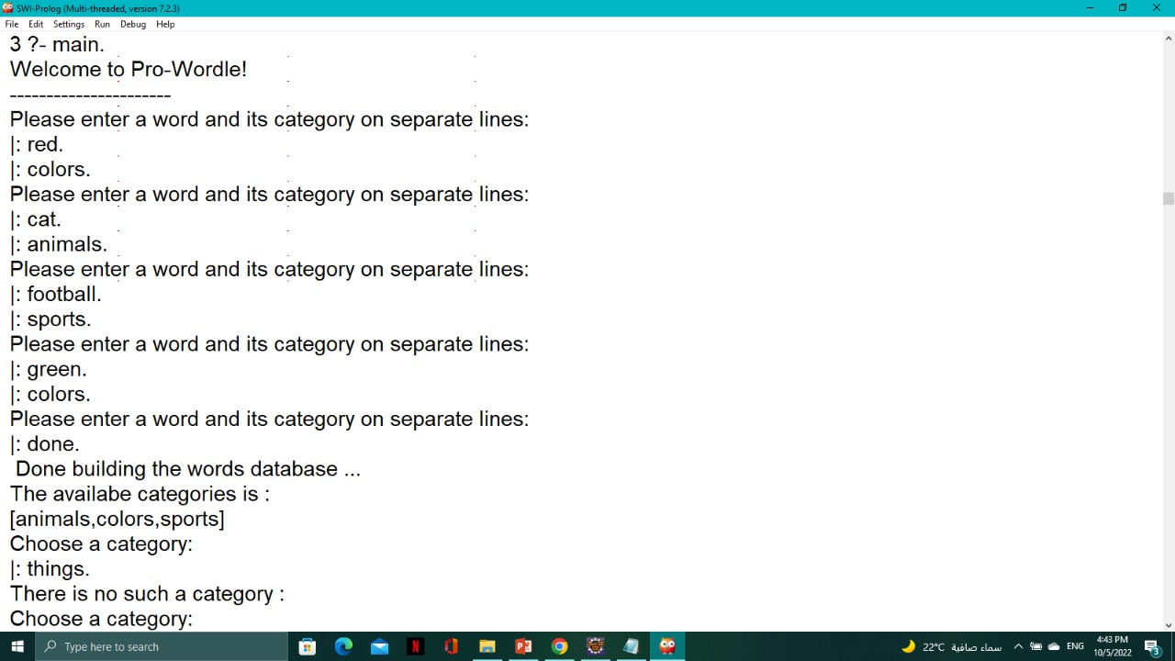

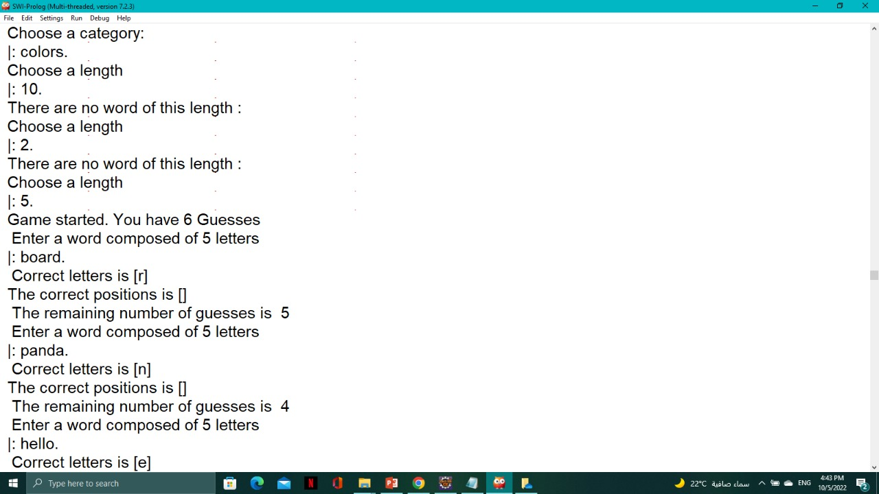

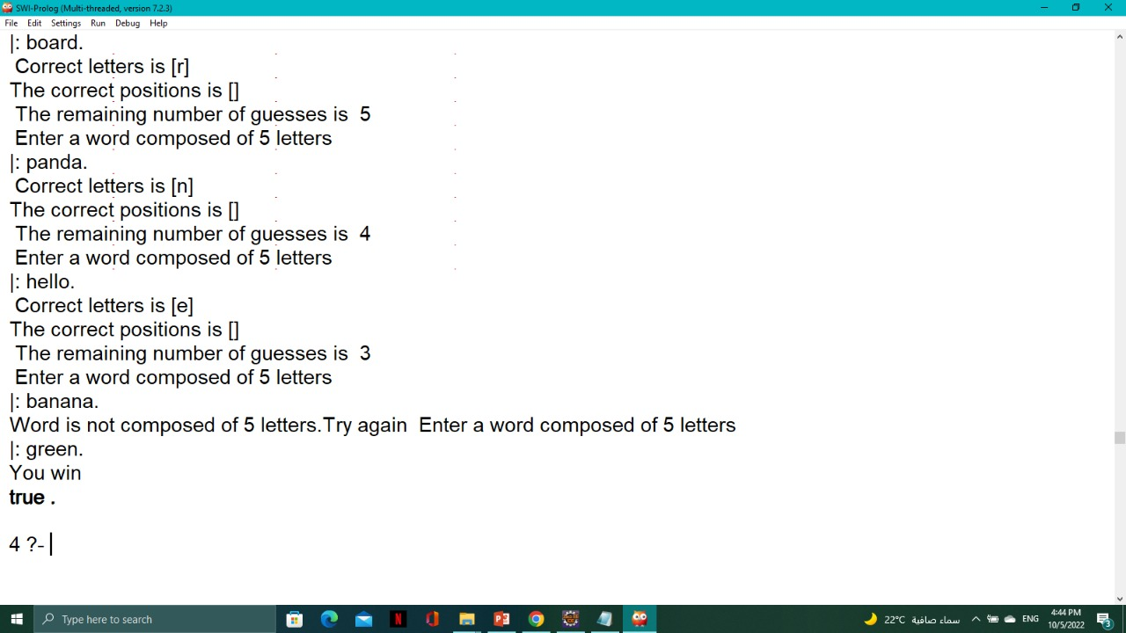

Case where the player loses

